**YOGA**

INTRODUCTION TO YOGA

Yoga is a holistic practice that integrates physical movement, breath control, meditation, and ethical living. Originating from ancient India, it is designed to foster a union between the body, mind, and spirit. Today, yoga is practiced worldwide, with millions engaging in various styles to enhance their physical fitness, mental clarity, and spiritual growth. This article will delve deeper into yoga’s rich history, its diverse forms, benefits, and how it continues to be relevant in today’s fast-paced lifestyle.



HISTORICAL BACKGROUND

The history of yoga is as rich and varied as the practice itself. The earliest mentions of yoga are found in the Vedic texts of around 1500 BCE, where it was associated with ritualistic practices and spiritual inquiry. Over centuries, yoga evolved, drawing influences from various philosophical traditions such as Samkhya and Vedanta.

* **The Upanishads**: These texts, composed between 800-400 BCE, introduced ideas about meditation, ethics, and the nature of the self, laying the groundwork for later yoga practices.
* **Patanjali’s Yoga Sutras**: Compiled around 200 CE, this foundational text codified yoga into an organized system, outlining the eight limbs of yoga (Ashtanga), which include ethical disciplines (yama and niyama), physical postures (asana), breath control (pranayama), sensory withdrawal (pratyahara), concentration (dharana), meditation (dhyana), and enlightenment (samadhi).
* **Hatha Yoga**: Emerging in the 9th century, Hatha Yoga focused on physical postures and breath, making it more accessible to the masses. It set the stage for modern styles of yoga, emphasizing the importance of physical health as a foundation for spiritual practice.
* **Globalization of Yoga**: In the late 19th and early 20th centuries, yoga began to gain traction in the West, introduced by influential figures such as Swami Vivekananda and later, B.K.S. Iyengar, who popularized Hatha Yoga and its therapeutic benefits. This cross-cultural exchange allowed yoga to adapt and integrate into various lifestyles, giving rise to the diverse forms we see today.

TYPES OF YOGA

Yoga encompasses a multitude of styles, each catering to different preferences, fitness levels, and goals. Here’s a closer look at some popular forms of yoga:

* **Hatha Yoga**: A foundational style that includes a range of physical postures and breathing techniques. It’s ideal for beginners, as it emphasizes alignment and stability.

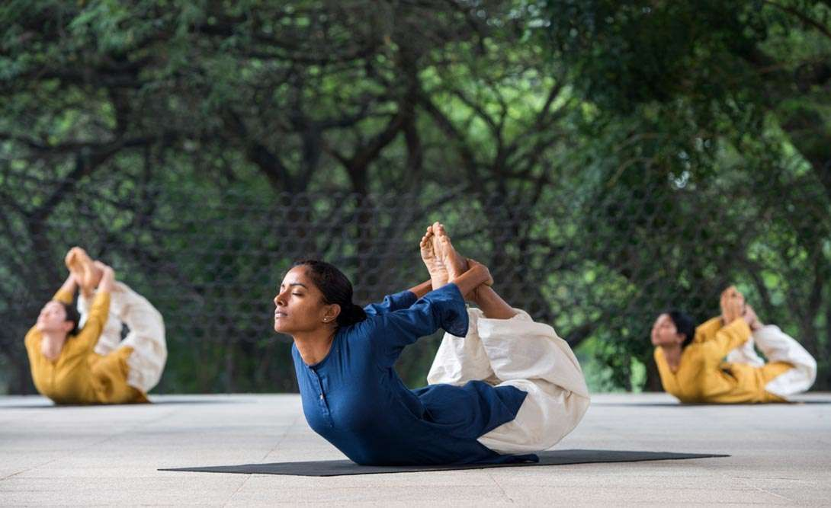

* **Vinyasa Yoga**: Known for its dynamic flow, Vinyasa links breath with movement, creating a seamless transition between poses. This style promotes cardiovascular fitness and is often characterized by creative sequencing.
* **Ashtanga Yoga**: A rigorous and structured practice involving a fixed sequence of postures performed in a specific order. It emphasizes strength, flexibility, and discipline, making it suitable for dedicated practitioners.
* **Bikram Yoga**: This style consists of a series of 26 postures performed in a heated room (around 105°F or 40°C). The heat aids in detoxification and flexibility, but it may be challenging for beginners.
* **Yin Yoga**: A slow-paced practice focusing on deep stretching and holding postures for extended periods. Yin Yoga targets connective tissues and promotes relaxation, making it ideal for stress relief and mindfulness.
* **Kundalini Yoga**: This practice combines physical postures, breathwork, chanting, and meditation to awaken kundalini energy. It emphasizes spiritual growth and self-awareness.
* **Restorative Yoga**: A gentle practice that uses props to support the body in restful postures. It promotes relaxation and stress relief, making it suitable for those recovering from illness or injury.

BENEFITS OF YOGA

Yoga offers a wealth of benefits that extend beyond physical fitness:

* **Physical Health**: Regular yoga practice can improve flexibility, strength, and balance. It can alleviate symptoms of chronic pain, improve posture, and enhance respiratory function. Scientific studies have shown that yoga can lower blood pressure, improve circulation, and boost overall cardiovascular health.
* **Mental Clarity**: Yoga encourages a mindful approach to life. Practitioners often experience enhanced concentration and cognitive abilities, which can lead to improved productivity and decision-making skills. Techniques learned in yoga can be applied to daily activities, fostering a more focused mindset.
* **Emotional Balance**: By promoting self-awareness and acceptance, yoga helps individuals manage stress and emotional upheaval. Practitioners frequently report improvements in mood and overall emotional well-being. The practice provides tools for coping with life’s challenges, fostering resilience and adaptability.
* **Enhanced Sleep Quality**: Many people find that yoga helps regulate their sleep patterns. Practices that emphasize relaxation, such as restorative yoga and gentle stretching, can promote better sleep quality and help combat insomnia.
* **Improved Relationships**: As yoga fosters emotional awareness and resilience, it can enhance interpersonal relationships. Practitioners often develop greater empathy, understanding, and communication skills, leading to healthier, more fulfilling connections with others.

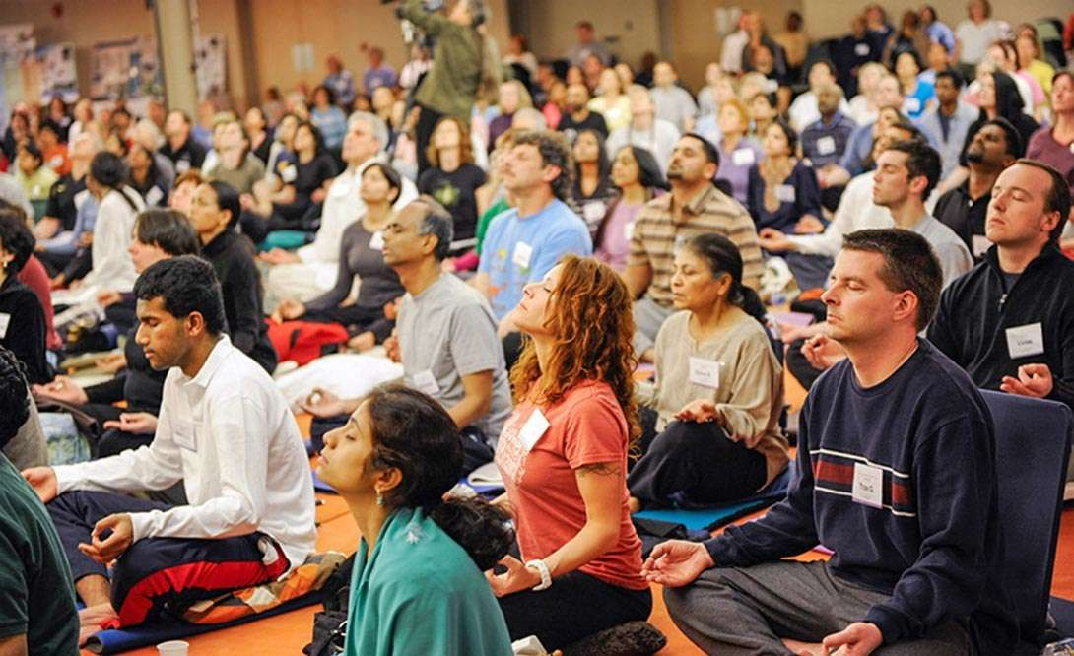

THE ROLE OF BREATH IN YOGA

Breath control, known as pranayama, is a fundamental component of yoga practice. It involves techniques that regulate the breath, which in turn influences energy flow (prana) within the body. Effective breath control enhances physical performance in asanas and deepens the meditative aspects of practice.

Key pranayama techniques include:

* **Ujjayi Breathing**: This technique involves constricting the throat slightly while breathing in and out through the nose, creating a soft sound. It enhances focus and promotes a sense of calm during practice.
* **Nadi Shodhana (Alternate Nostril Breathing)**: This technique balances the left and right hemispheres of the brain, promoting mental clarity and emotional stability. It is often used to reduce anxiety and enhance concentration.
* **Kapalabhati (Skull Shining Breath)**: A vigorous breathing technique that involves short, forceful exhales followed by passive inhales. This energizes the body, clears the mind, and stimulates digestion.
* **Deep Belly Breathing**: Also known as diaphragmatic breathing, this technique promotes relaxation and stress reduction by engaging the diaphragm and encouraging full oxygen exchange.

Through these techniques, practitioners learn to cultivate awareness of their breath, which can be a powerful tool for stress management and emotional regulation.

YOGA AND MENTAL HEALTH

The mental health benefits of yoga are increasingly recognized by researchers and mental health professionals alike. Here are several ways yoga contributes to improved mental well-being:

* **Mindfulness and Presence**: Yoga encourages practitioners to focus on the present moment, fostering a state of mindfulness. This awareness helps break the cycle of negative thought patterns and reduces anxiety.
* **Stress Reduction**: The combination of physical movement, breath control, and meditation helps activate the body’s relaxation response. Regular practice can lower cortisol levels, the hormone associated with stress, leading to a more balanced emotional state.
* **Emotional Awareness**: Yoga promotes emotional awareness by encouraging practitioners to tune into their feelings. This self-awareness helps individuals process emotions effectively and develop healthier coping mechanisms.
* **Community Support**: Engaging in group yoga classes fosters a sense of community and belonging. This support can reduce feelings of isolation and promote social connections, which are vital for mental health.
* **Therapeutic Applications**: Many therapists incorporate yoga into their treatment plans for various mental health issues, such as PTSD, anxiety, and depression. Yoga’s holistic approach addresses both physical and emotional aspects of well-being, making it a valuable adjunct to traditional therapies.

YOGA IN MODERN SOCIETY

In today’s fast-paced world, yoga has emerged as a vital practice for enhancing overall health and well-being. Its popularity can be attributed to several factors:

* **Accessibility**: The rise of online yoga classes and apps has made yoga accessible to a broader audience. Practitioners can explore various styles and instructors from the comfort of their homes, allowing for personalized experiences.
* **Workplace Integration**: Many organizations recognize the benefits of yoga for employee wellness and productivity. Offering on-site classes or wellness programs has become a common practice, helping to reduce stress and improve workplace morale.
* **Cultural Inclusivity**: Yoga communities are increasingly diverse, bringing together individuals from various backgrounds. This inclusivity fosters a sense of belonging and encourages shared experiences, enriching the practice for everyone involved.
* **Lifestyle Integration**: Many practitioners embrace yoga as a way of life, incorporating its principles into daily routines. This holistic approach emphasizes mindfulness, healthy eating, and ethical living, creating a more balanced and fulfilling lifestyle.

PRACTICING YOGA: TIPS FOR BEGINNERS



Starting a yoga practice can be both exciting and daunting. Here are some essential tips for beginners to ease into the journey:

* **Choose the Right Class**: Look for beginner-friendly classes that focus on foundational postures and techniques. Many studios offer introductory packages or workshops to help newcomers acclimate.
* **Invest in Quality Gear**: While high-end gear isn’t necessary, a good-quality yoga mat can enhance your practice. Wear comfortable clothing that allows for freedom of movement.
* **Listen to Your Body**: Every body is unique, and yoga is a personal journey. Pay attention to how your body feels during practice, and avoid pushing yourself into.